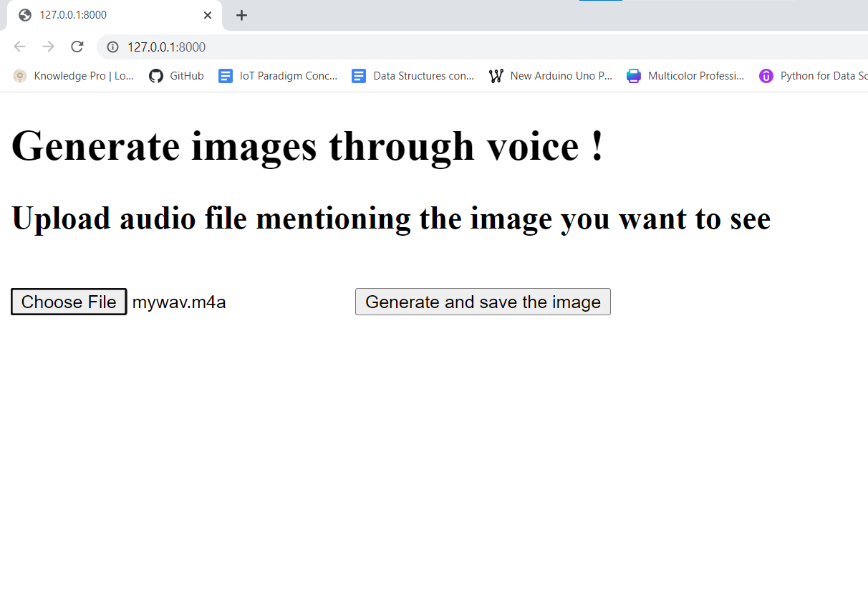

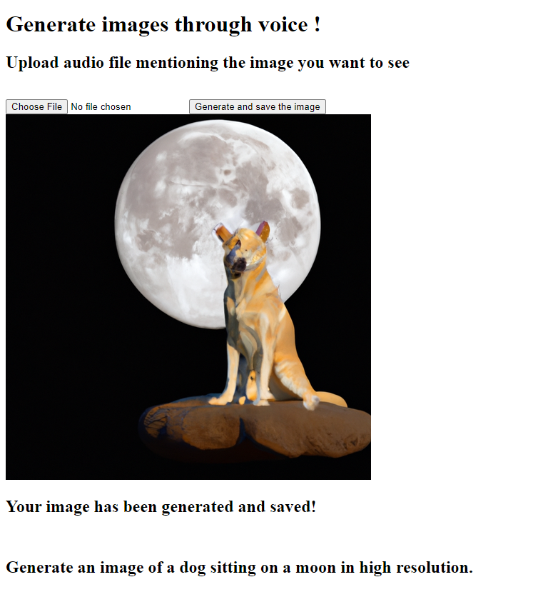

The aim of the project is to make a website to allow users to create an image from an audio file

The generated image URL and transcribed text will be saved into a Django database.

Here Django and sqlite3 has been used to save the image URL and text which could be retrieved later for use.

Audio file will have to be recorder and uploaded externally

GRadio module has been removed.